Sprint 2 Report

Scrum Tools, by the Scrum Mates, 2/24/2024

# Actions to start doing

The team should start staying unmuted during standup meetings and turning on cameras whenever possible to help keep us accountable to our updates. The frontend tasks should be broken down into further tasks so that they can be individually selected and doesn’t depend on one person to finish. The team should also start texting in the Discord more frequently to communicate their needs or blockers with the rest of the team and so we can stay better informed. The team should plan some group working sessions between standup meetings so there is some designated time to work on the project.

# Actions to stop doing

The team should also stop treating this class as less urgent than other classes because it is hindering the amount of time we spent on the project. The team should also stop staying silent for most of the meetings so they can contribute their ideas to the group and help us do better.

# Actions to keep doing

The team should continue maintaining the Scrum documents because it helps to stay organized. The unit tests were also useful to know when a bug occurred or something was not working because of a change. The team should keep having a short design meeting every week as well to generate new ideas and keep everyone up to date.

# Work Completed/Not completed

Completed tasks and stories are crossed out

### Story 1

| **Priority** | **Story** | **Acceptance Criteria** | **SP** |
| --- | --- | --- | --- |
| 1 - Must | As a product owner, I want to create new release plans so I can add to previous plans and communicate my plan to the team. | Have a good form for inputting and editing a release plan  Be able to create a new release plan based on the current release plan  Changes can be saved.  Have automatically generated version numbers depending on if a release plan is created fresh, or if it is a revision of a previous release plan.  Team can see all versions (previous versions, signed versions, unsigned versions) of the release plan. | 5 |

| **Tasks** | **Ideal Hours** |
| --- | --- |
| 1. ~~Design a page to view release plans~~ | ~~2~~ |
| 1. Implement the design into the app | 3 |
| 1. ~~Implement the Project, Release Plan, Sprint Plan entities for TypeORM~~ | ~~4~~ |
| 1. ~~Create new backend functions to make a copy of a release plan~~ | ~~1~~ |
| 1. ~~Create new backend functions to save release plans~~ | ~~1~~ |
| 1. Opening a release plan loads it into the editor | 2 |
| 1. ~~Create new backend functions to get previous release plans’ versions~~ | ~~3~~ |

# Work Completion Rate

Average user stories/day and average ideal work hours/day figures computed across all sprints to date.

Total number of user of stories completed during the prior sprint: 0

Total number of estimated ideal work hours completed during the prior sprint: 11

Total number of days during the prior sprint: 7 days

User Stories/day = 0/7 = 0 stories/day

Average user stories/day = avg(0) = 0 stories/day

Ideal hours/day = 11/7 = 1.57 ideal hours/day

average ideal hours/day = avg(.86, 1.57) = 1.216 ideal hours/day

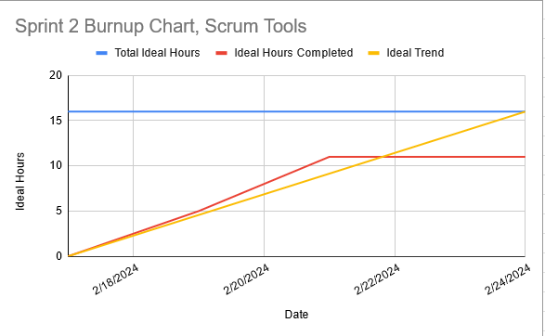

# Completed Scrum Board

